**https://www.linkedin.com/in/gayatri-mishra-freelancecoach/**

Setting-up cypress in winows machine

**Introduction:**

Cypress is a test automation tool.

It can test anything that runs on a web browser.

It supports java script and type script.

Cypress is open source.

Official page .. cypress.io

Work flow :

Setup -> write -> run -> debug

Supports browsers : chrome , firefox , edge ect

**Features of cypress :**

Time travel : takes screen shots as the test runs.

Debug ability : Readable errors and stack trace.

Automatic waits: Do not need to add custom waits.

Cypress enables us to use all types of test :

1. End to end test
2. Integration testing
3. Unit testing

Machine requirement :

# windows 7 and above

#mac os 10.9 or above

#Linux : 12.4

**https://www.linkedin.com/in/gayatri-mishra-freelancecoach/**

Installation steps :

Installing cypress using node js.

To check whether node is installed or not ..

* Open command prompt
* Enter the command node –version
* It shall show you the node version

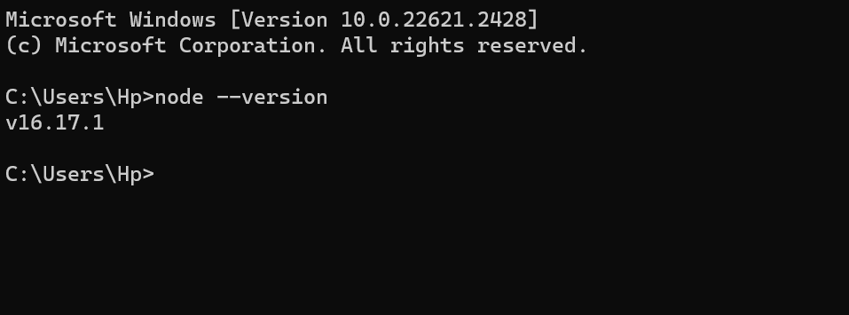

Execute npm –v

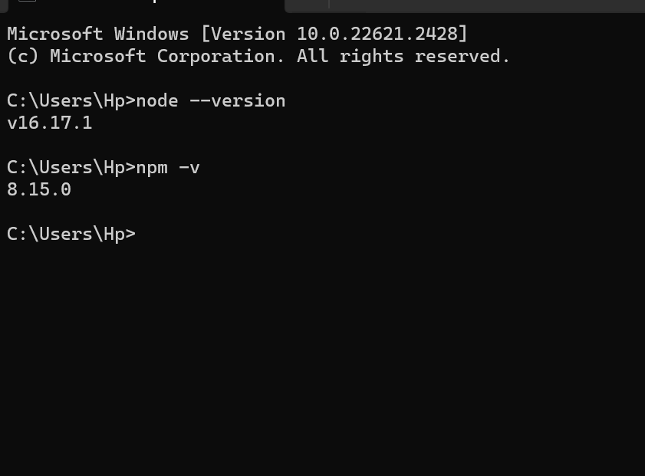

Npm : node package manager.

Visual studio code must be installed.

Run the command npm init –y from terminal.

To open terminal >

View-> terminal

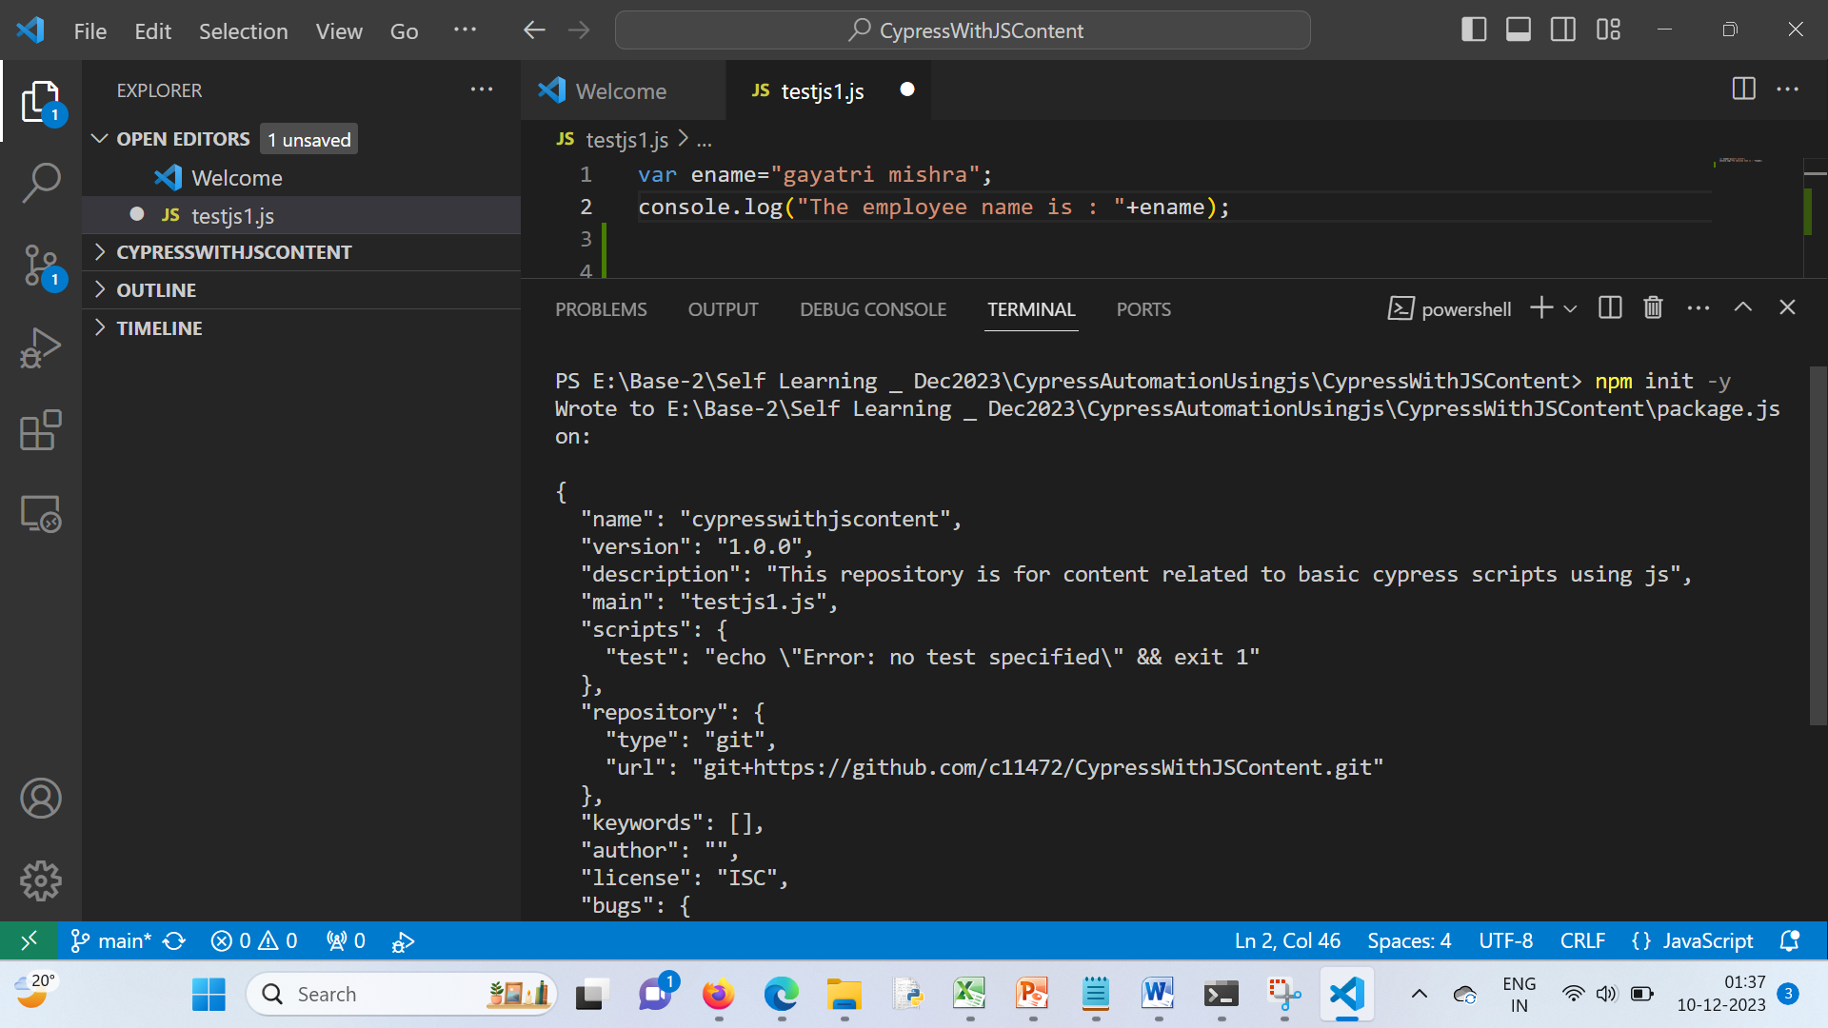

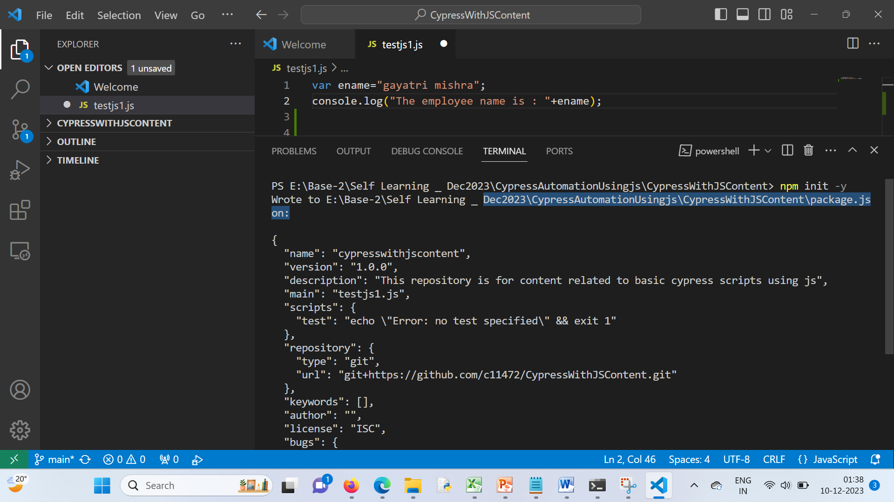

Package.json newly added file in our project used for dependency management

To install cypress

npm install cypress

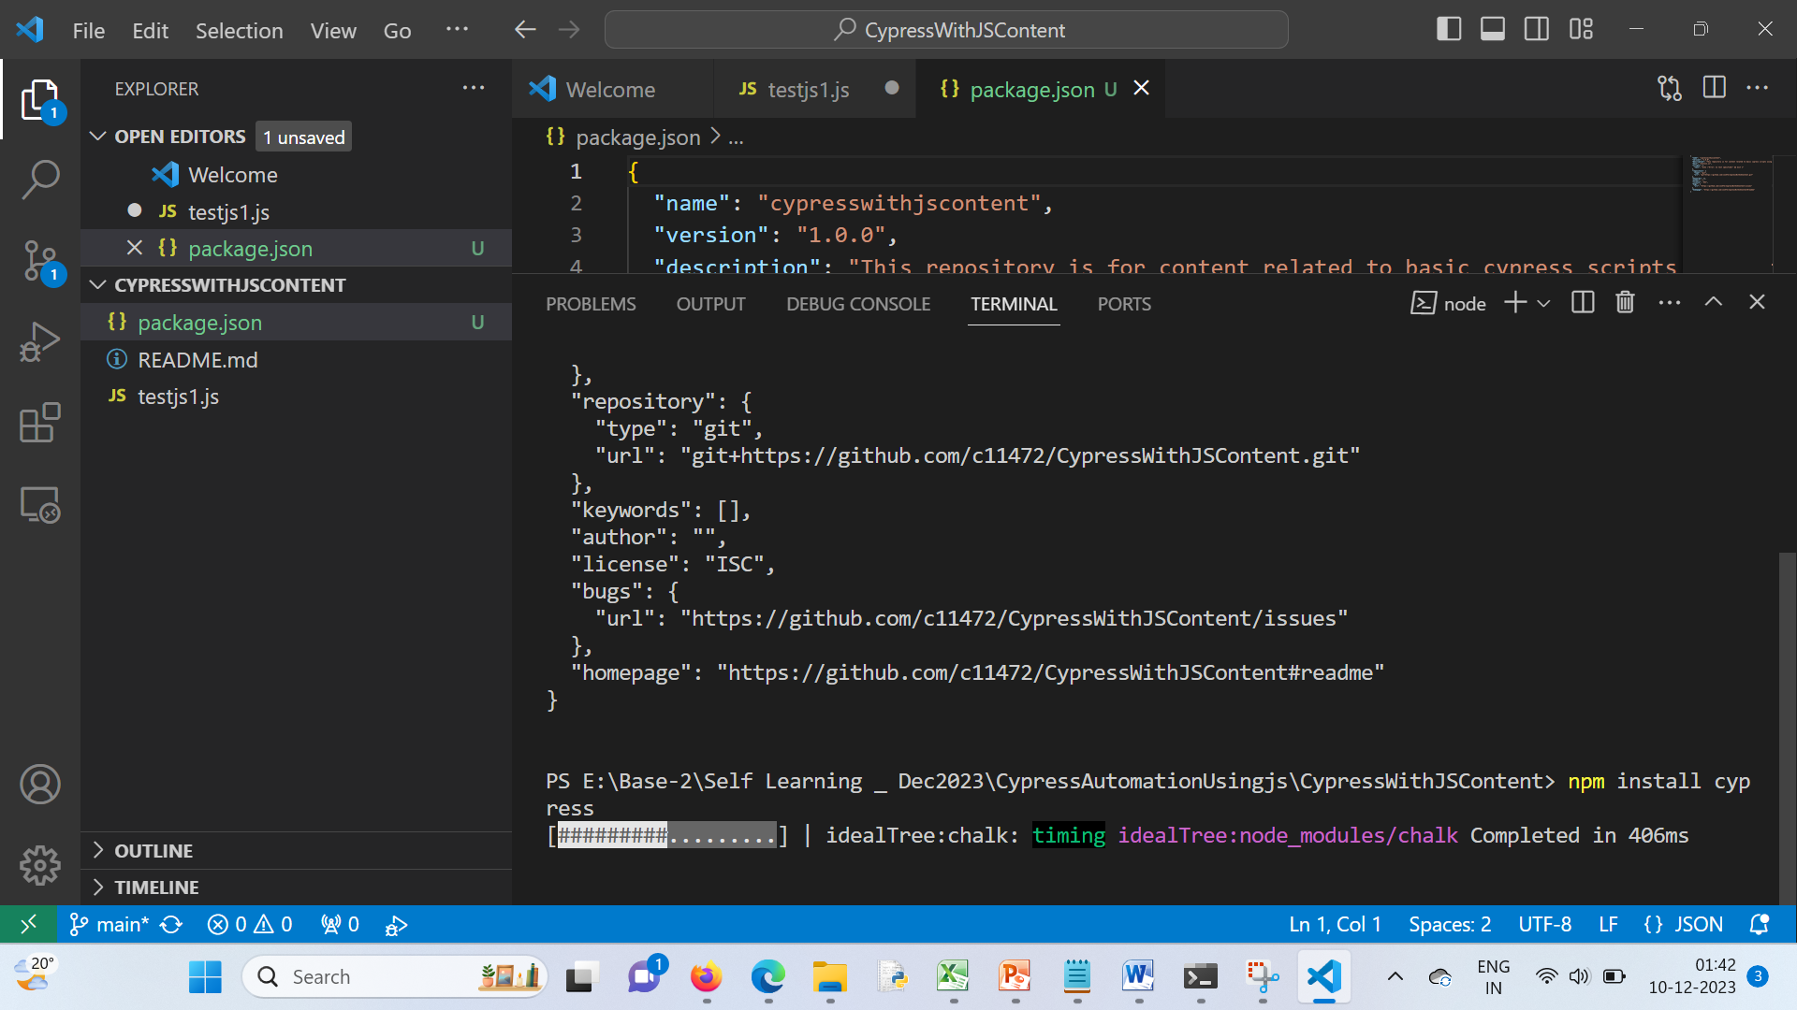

npx cypress –v

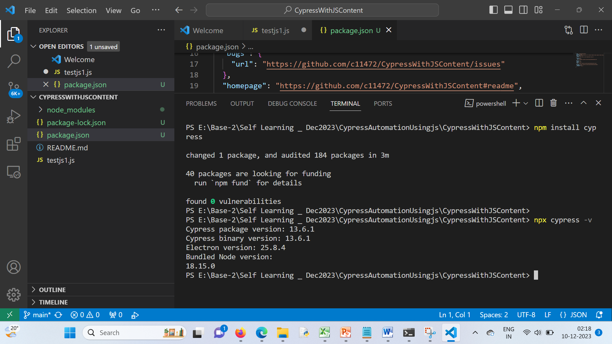

To open cypress:

npx cypress open

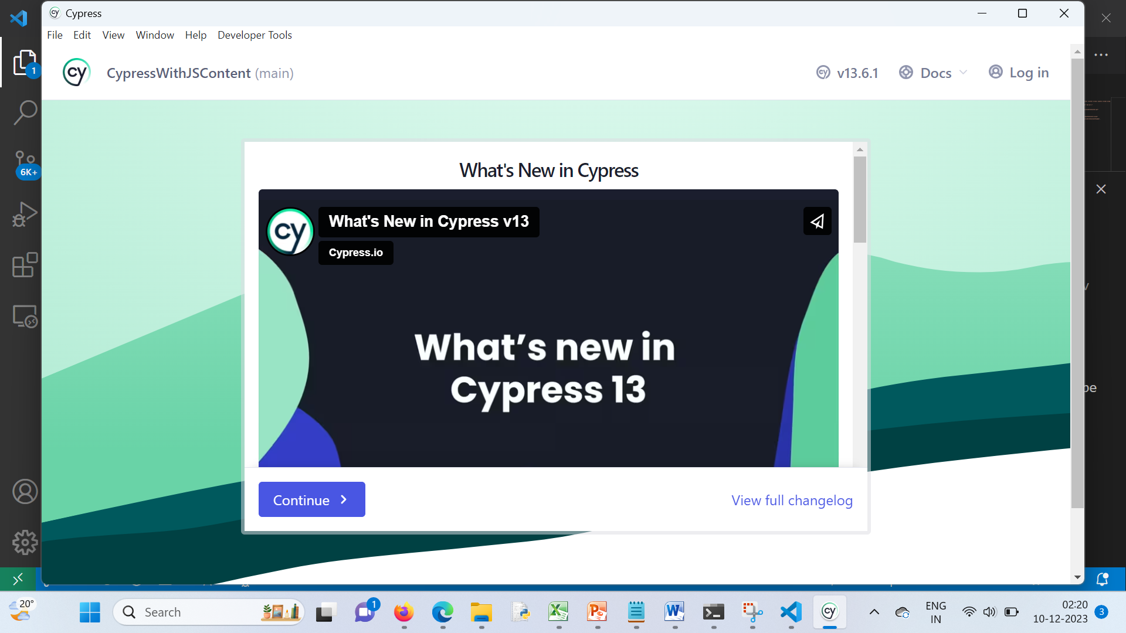

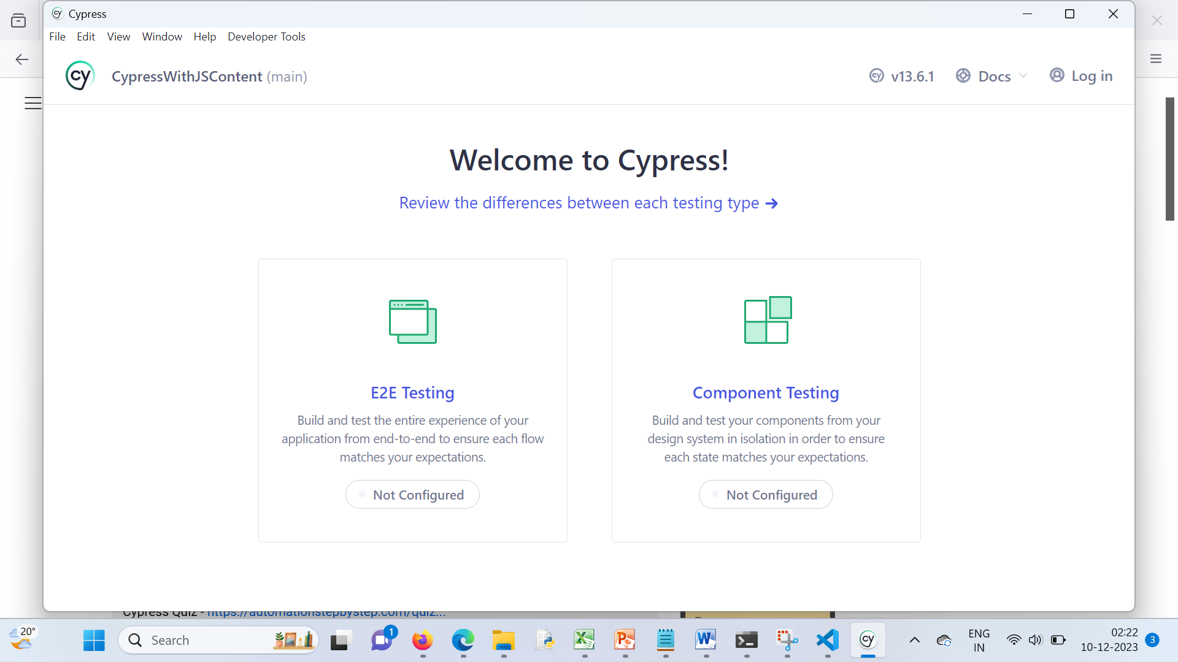

Final:

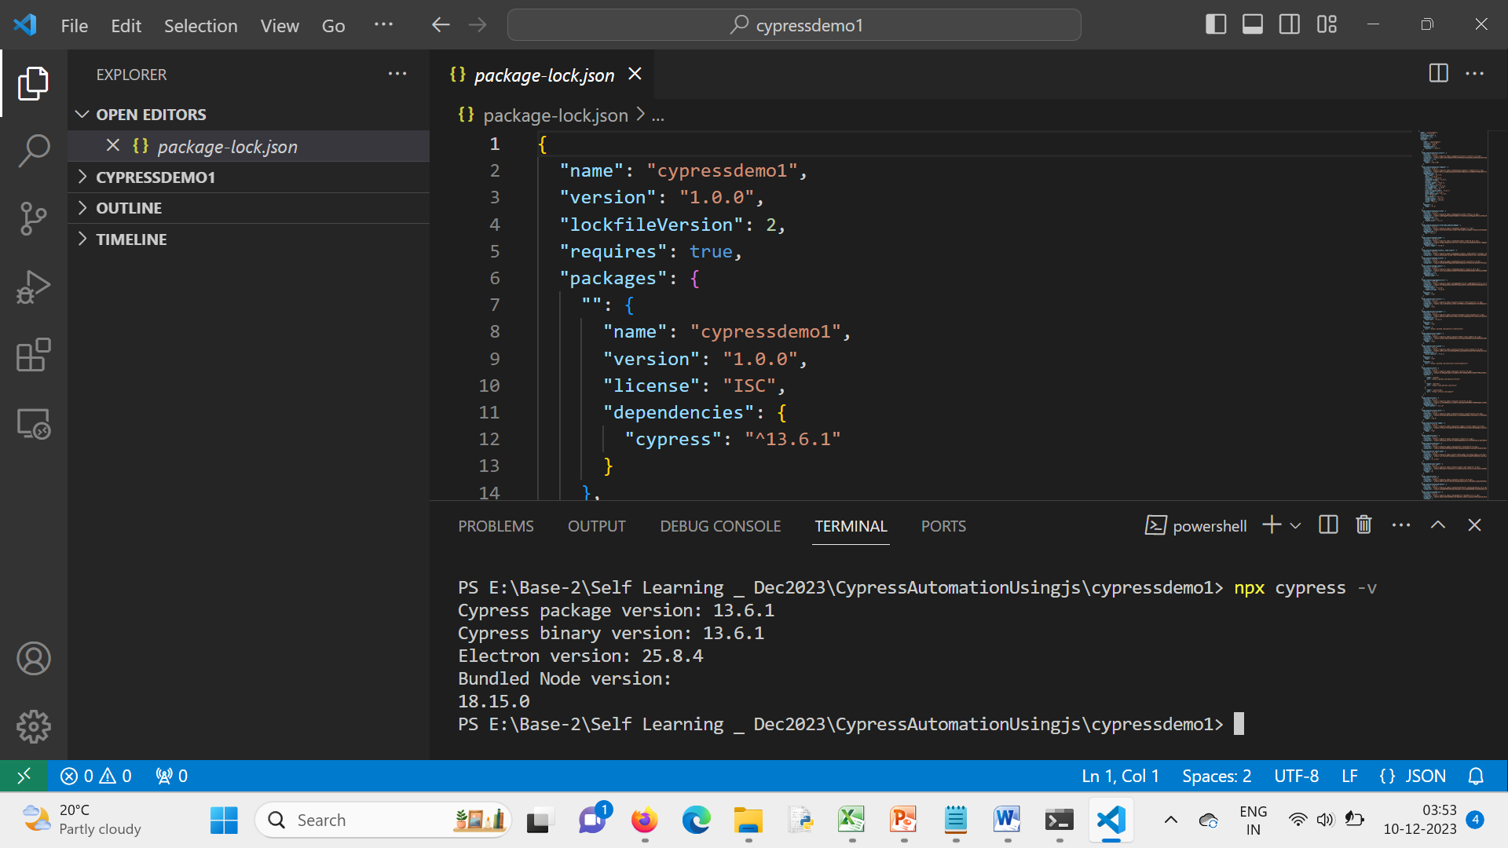

/// <reference types="cypress"/>

describe('First test suite',() =>{

    /*it('first test',()=>{

        cy.visit(')

    })*/

    it('google test',function(){

        cy.visit('https://www.google.com/')

    })

})

const { defineConfig } = require('cypress')

  module.exports = defineConfig({

  viewportHeight: 1080,

  viewportWidth: 1920,

  video: false,

  e2e: {

    baseUrl: 'https://www.google.com/',

    excludeSpecPattern: ['**/1-getting-started','**/2-advanced-examples'],

    specPattern: 'cypress/e2e/**/*.cy.{js,jsx,ts,tsx}',

    setupNodeEvents(on,config){

    }

  },

})

How many ways we can execute the script ?

1. npx cypress run
2. npx cypress run –spec <Relative file path>
3. npx cypress run --browser chrome --headed

Alternately open the cypress

npx cypress open

Run from cypress ui.

Locators :

Cypress supports cssSelector

Xpath -> require plugin cypress xpath plugin